BÀI TẬP: THỰC HÀNH CẤU HÌNH PORT-SECURITY
1. Sơ đồ
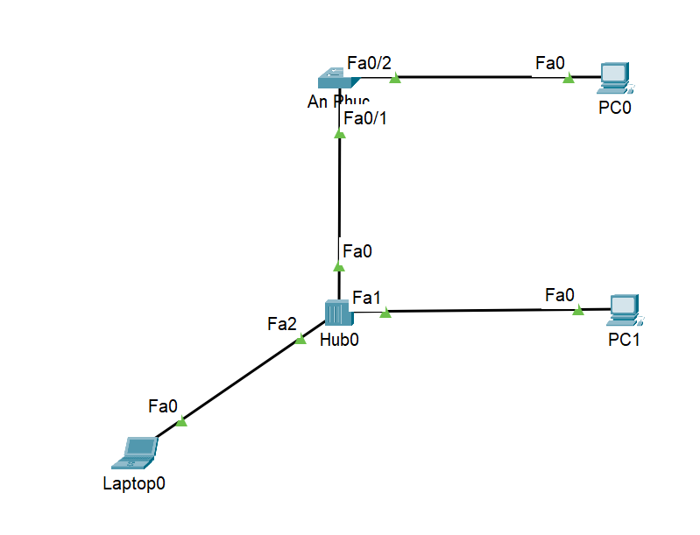
2. Lệnh cấu hình
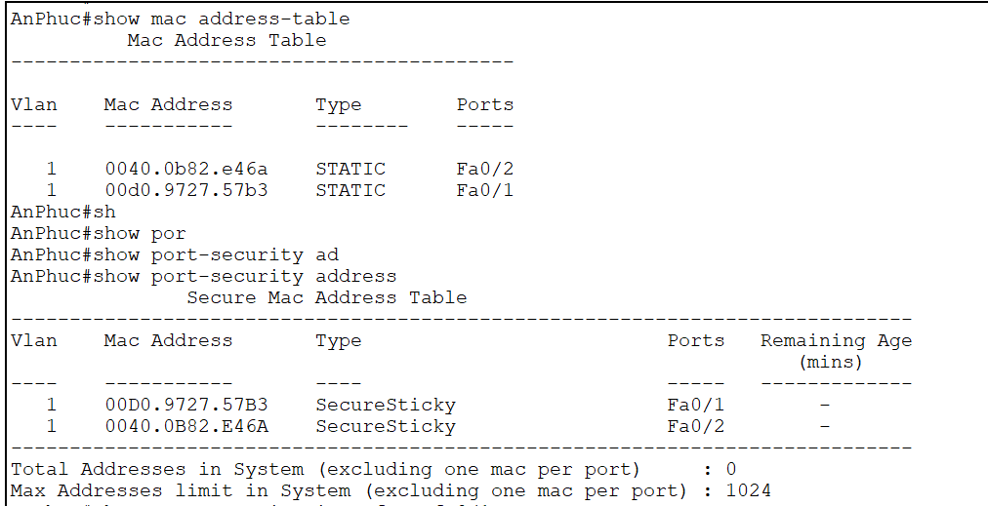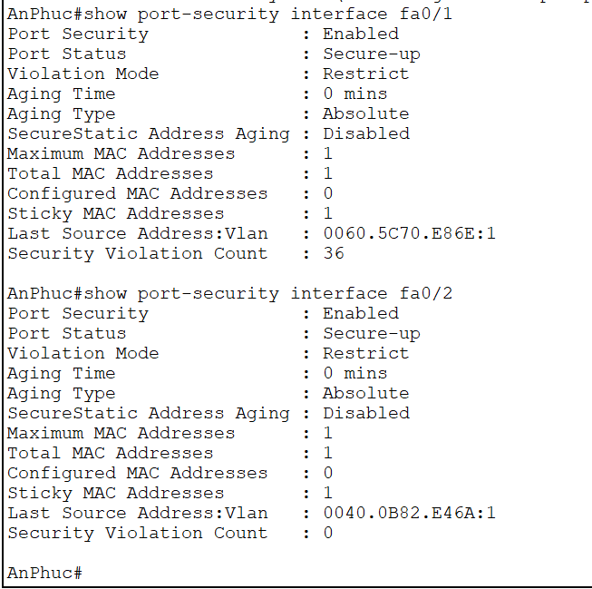

AnPhuc#show mac address-table
Mac Address Table
-------------------------------------------

Vlan Mac Address Type Ports
---- ----------- -------- -----

1 0040.0b82.e46a STATIC Fa0/2
1 00d0.9727.57b3 STATIC Fa0/1
AnPhuc#sh
AnPhuc#show por
AnPhuc#show port-security ad
AnPhuc#show port-security address
Secure Mac Address Table
-----------------------------------------------------------------------------
Vlan Mac Address Type Ports Remaining Age
(mins)
---- ----------- ---- ----- -------------
1 00D0.9727.57B3 SecureSticky Fa0/1 -
1 0040.0B82.E46A SecureSticky Fa0/2 -
-----------------------------------------------------------------------------
Total Addresses in System (excluding one mac per port) : 0
Max Addresses limit in System (excluding one mac per port) : 1024
AnPhuc#show port-security interface fa0/1
Port Security : Enabled
Port Status : Secure-up
Violation Mode : Restrict
Aging Time : 0 mins
Aging Type : Absolute
SecureStatic Address Aging : Disabled
Maximum MAC Addresses : 1
Total MAC Addresses : 1
Configured MAC Addresses : 0
Sticky MAC Addresses : 1
Last Source Address:Vlan : 0060.5C70.E86E:1
Security Violation Count : 36

AnPhuc#show port-security interface fa0/2
Port Security : Enabled
Port Status : Secure-up
Violation Mode : Restrict
Aging Time : 0 mins
Aging Type : Absolute
SecureStatic Address Aging : Disabled
Maximum MAC Addresses : 1
Total MAC Addresses : 1
Configured MAC Addresses : 0
Sticky MAC Addresses : 1
Last Source Address:Vlan : 0040.0B82.E46A:1
Security Violation Count : 0
AnPhuc#
3. Kết quả : PC1 ping được, PC0 không ping được
4. Lệnh show running
AnPhuc#show running-config
Building configuration...

Current configuration : 1704 bytes
!
version 15.0
no service timestamps log datetime msec
no service timestamps debug datetime msec
no service password-encryption
!
hostname AnPhuc
!
!
!
!
!
!
spanning-tree mode pvst
spanning-tree extend system-id
!
interface FastEthernet0/1
switchport mode access
switchport port-security
switchport port-security mac-address sticky
switchport port-security violation restrict
switchport port-security mac-address sticky 00D0.9727.57B3
!
interface FastEthernet0/2
switchport mode access
switchport port-security
switchport port-security mac-address sticky
switchport port-security violation restrict
switchport port-security mac-address sticky 0040.0B82.E46A
!
interface FastEthernet0/3
shutdown
!
interface FastEthernet0/4
shutdown
!
interface FastEthernet0/5
shutdown
!
interface FastEthernet0/6
shutdown
!
interface FastEthernet0/7
shutdown
!
interface FastEthernet0/8
shutdown
!
interface FastEthernet0/9
shutdown
!
interface FastEthernet0/10
shutdown
!
interface FastEthernet0/11
shutdown
!
interface FastEthernet0/12
shutdown
!
interface FastEthernet0/13
shutdown
!
interface FastEthernet0/14
shutdown
!
interface FastEthernet0/15
shutdown
!
interface FastEthernet0/16
shutdown
!
interface FastEthernet0/17
shutdown
!
interface FastEthernet0/18
shutdown
!
interface FastEthernet0/19
shutdown
!
interface FastEthernet0/20
shutdown
!
interface FastEthernet0/21
shutdown
!
interface FastEthernet0/22
shutdown
!
interface FastEthernet0/23
shutdown
!
interface FastEthernet0/24
shutdown
!
interface GigabitEthernet0/1
!
interface GigabitEthernet0/2
!
interface Vlan1
no ip address
shutdown
!
!
!
!
line con 0
!
line vty 0 4
login
line vty 5 15
login
!
!
!
!
end

AnPhuc#

